[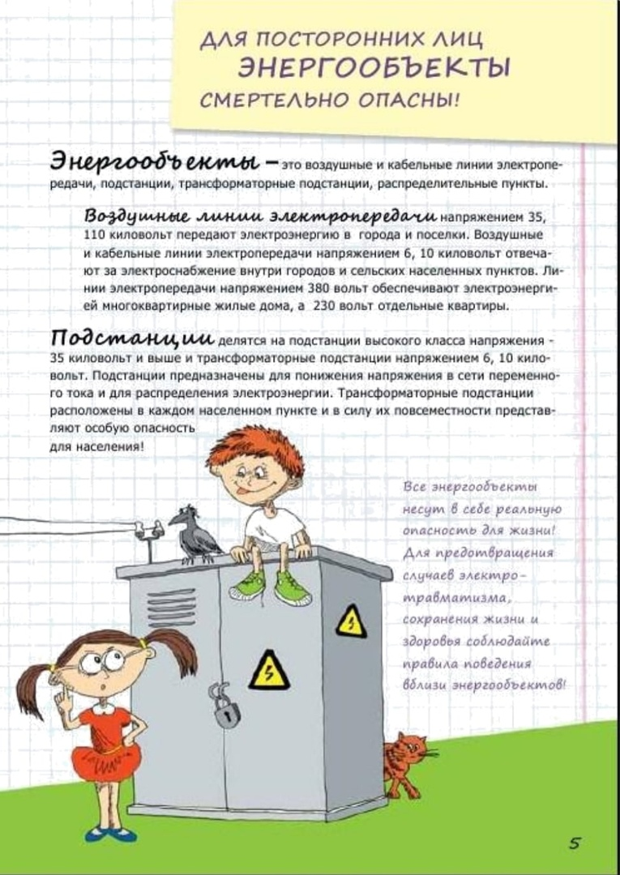](https://school12-vyksa.nnov.eduru.ru/media/2020/06/02/1255063934/G9Gu0TjRh84.jpg)